

Paint, Body and Equipment Trade Show

Monday, February 11th, 2019
- 5:00 p.m. to 9:00 p.m.
- 250 Kalahari Drive, Pocono Manor, Pa.
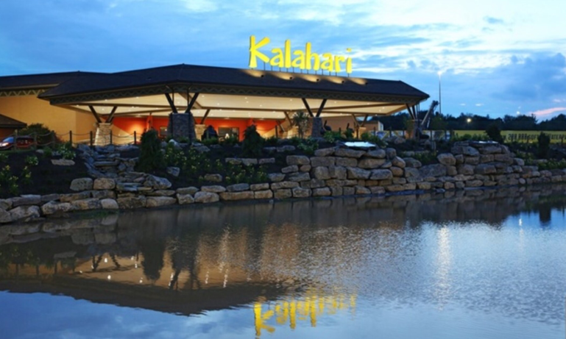
Join us and 70+ of the Industry’s Top Manufacturers.
- Show Only Promotions
- Food and Refreshments
- PPG Recertification Training
- PPG MVP Sampler Seminar
- Manufacture’s Seminars
- Reduced Resort Room Rates
- OEM Shop Certification Information Seminar

